Contents

React Project 1 2

**Task 1**: Create a Header that will be displayed across all pages 2

Display: 2

Code: 2

**Task 2:** Create a Homepage that displays the list of notes 2

Display: 2

**Task 3:** Create a Row component 3

Code: 3

Display: 3

**Task 4:** Create an Add Note page 5

Display: 5

**Task 5:** Create an Edit Note page 7

Display: 7

**Task 6:** Use an npm package 8

Code: 8

# React Project 1

## **Task 1**: Create a Header that will be displayed across all pages

### Display:

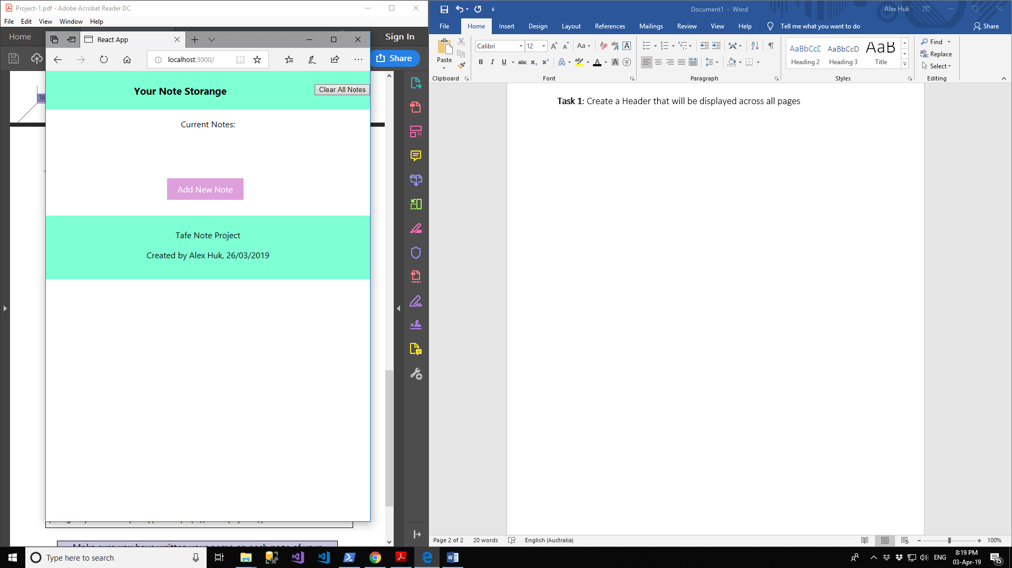

### Code:

const Header = function(){

return(

<div className="header">

<title>Your Note Storange</title>

<h3 className="title">

Your Note Storange

<button onClick={() => {

localStorage.removeItem('list');

window.location.reload();

}} className="clearButton">

Clear All Notes

</button>

</h3>

</div>

);

}

## **Task 2:** Create a Homepage that displays the list of notes

### Display:

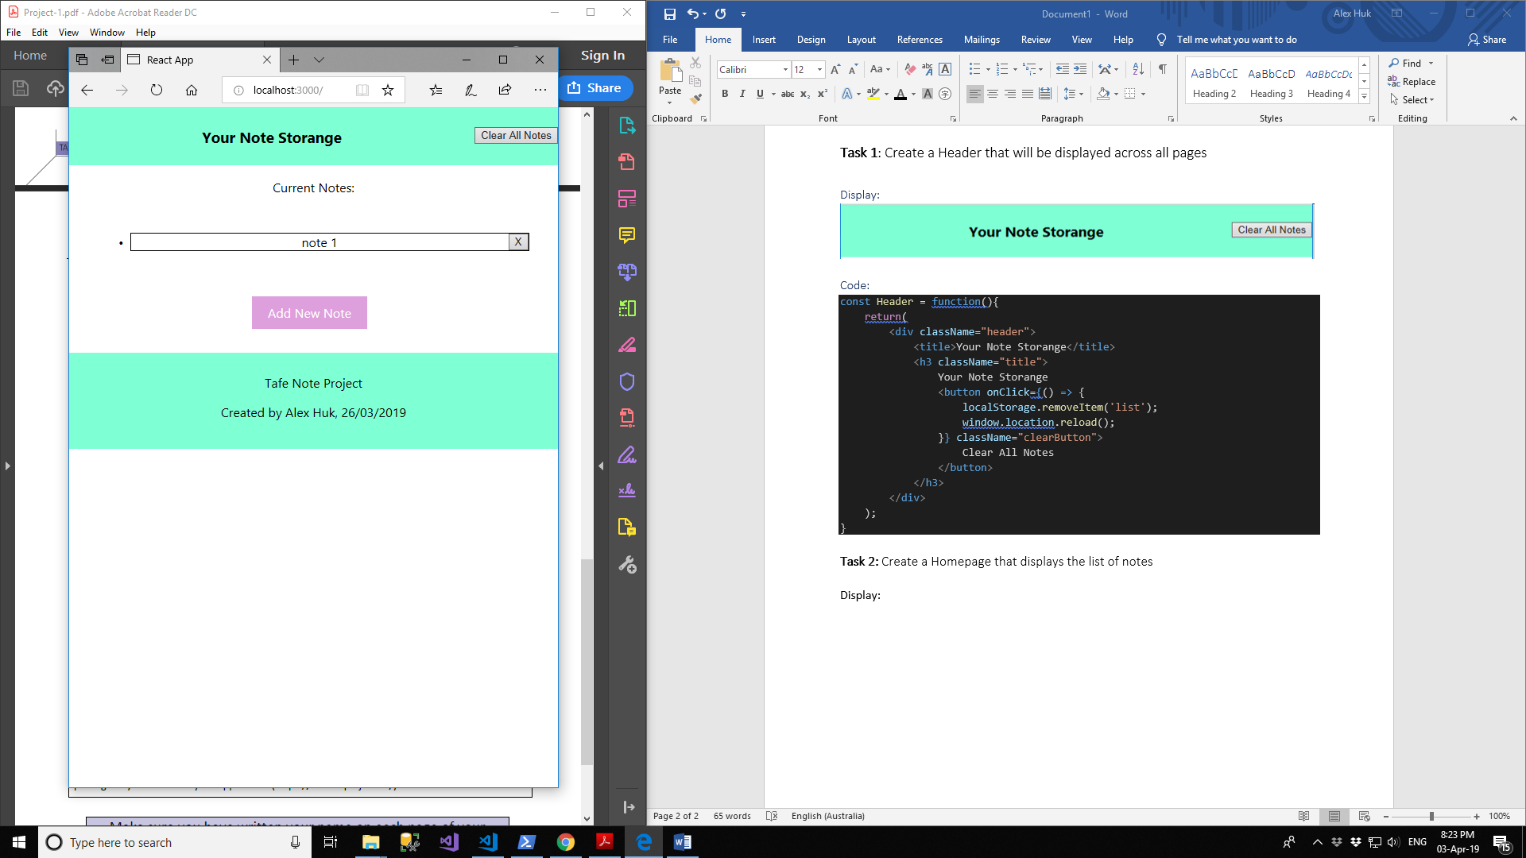

## **Task 3:** Create a Row component

### Code:

const Row = function(props) {

return(

<li className="rowlist" onClick={props.onClick}>

{props.title}

<button onClick={props.onDelete} className="button">X</button>

</li>

);

};

### Display:

Row:



Delete

Title

Row Component

When click on row, send to Edit page:

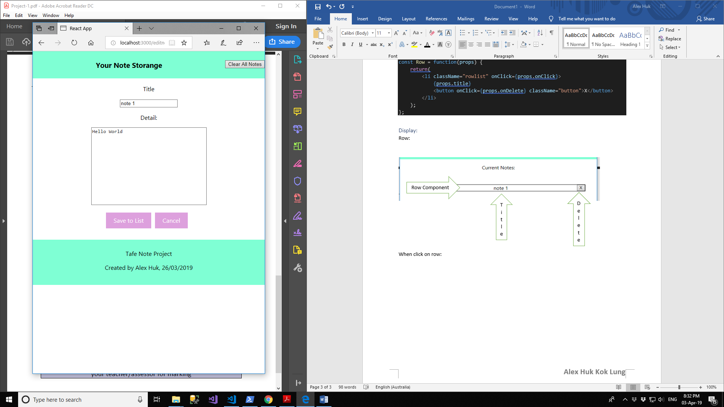

When click Delete button, remove from list:

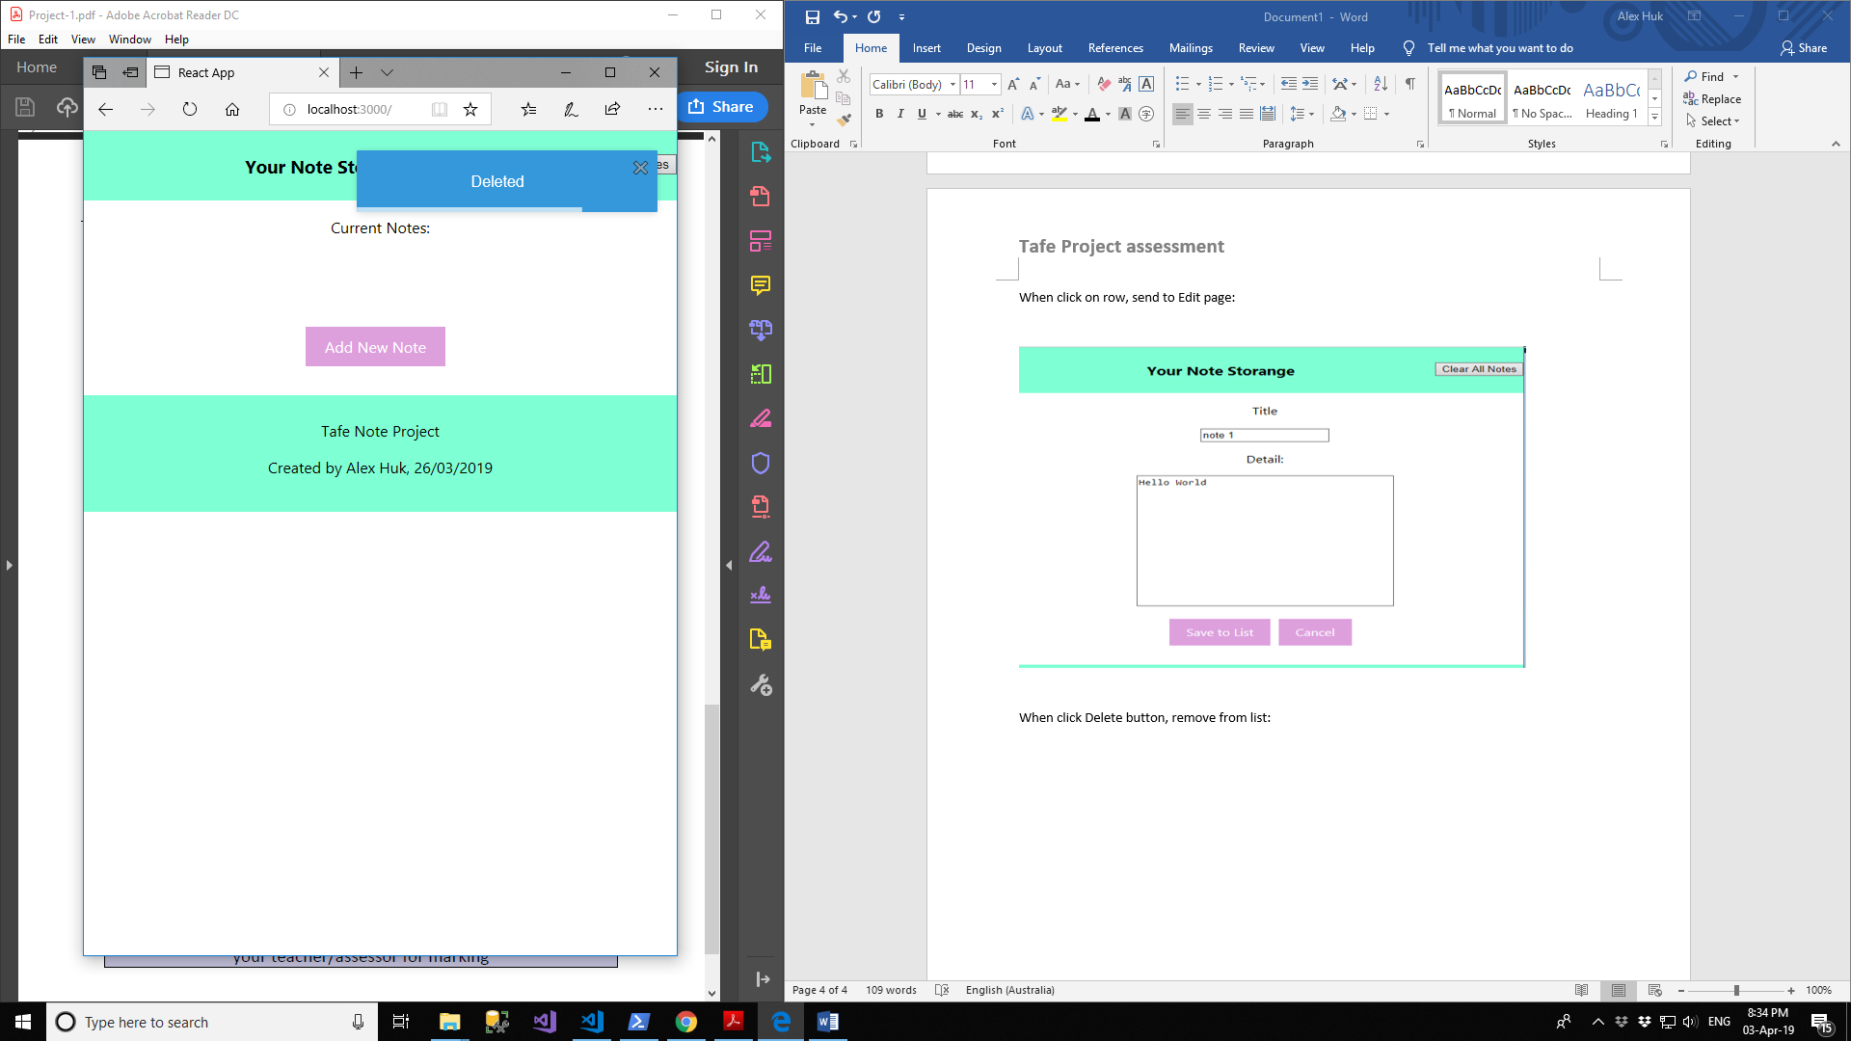

## **Task 4:** Create an Add Note page

### Display:

Click on Add New Note button:

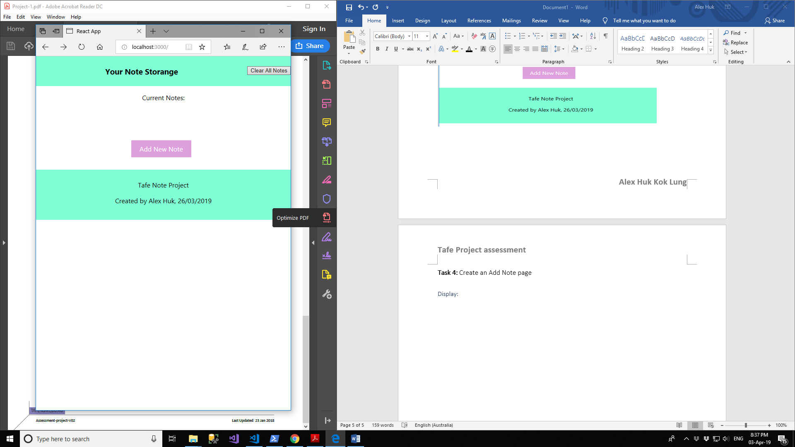

Send to Add Note page:

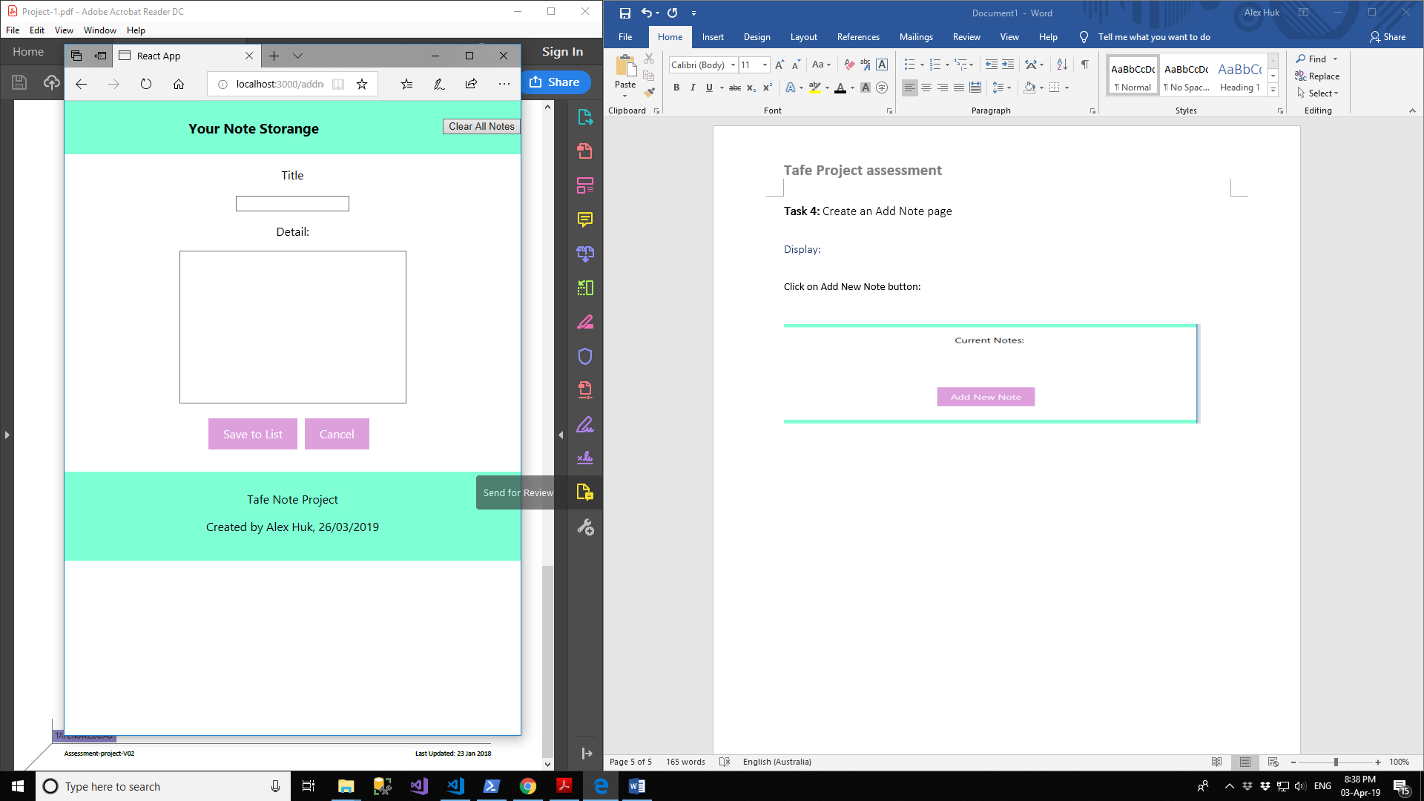

Enter some note, click Save To List button:

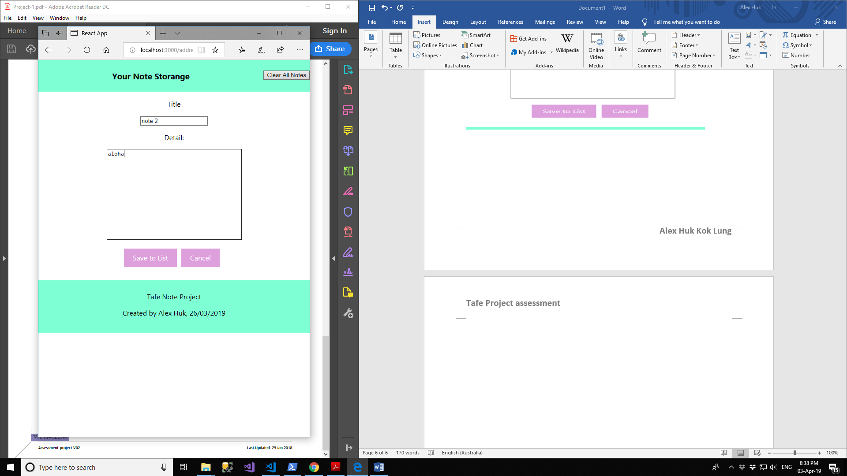

Note saved:

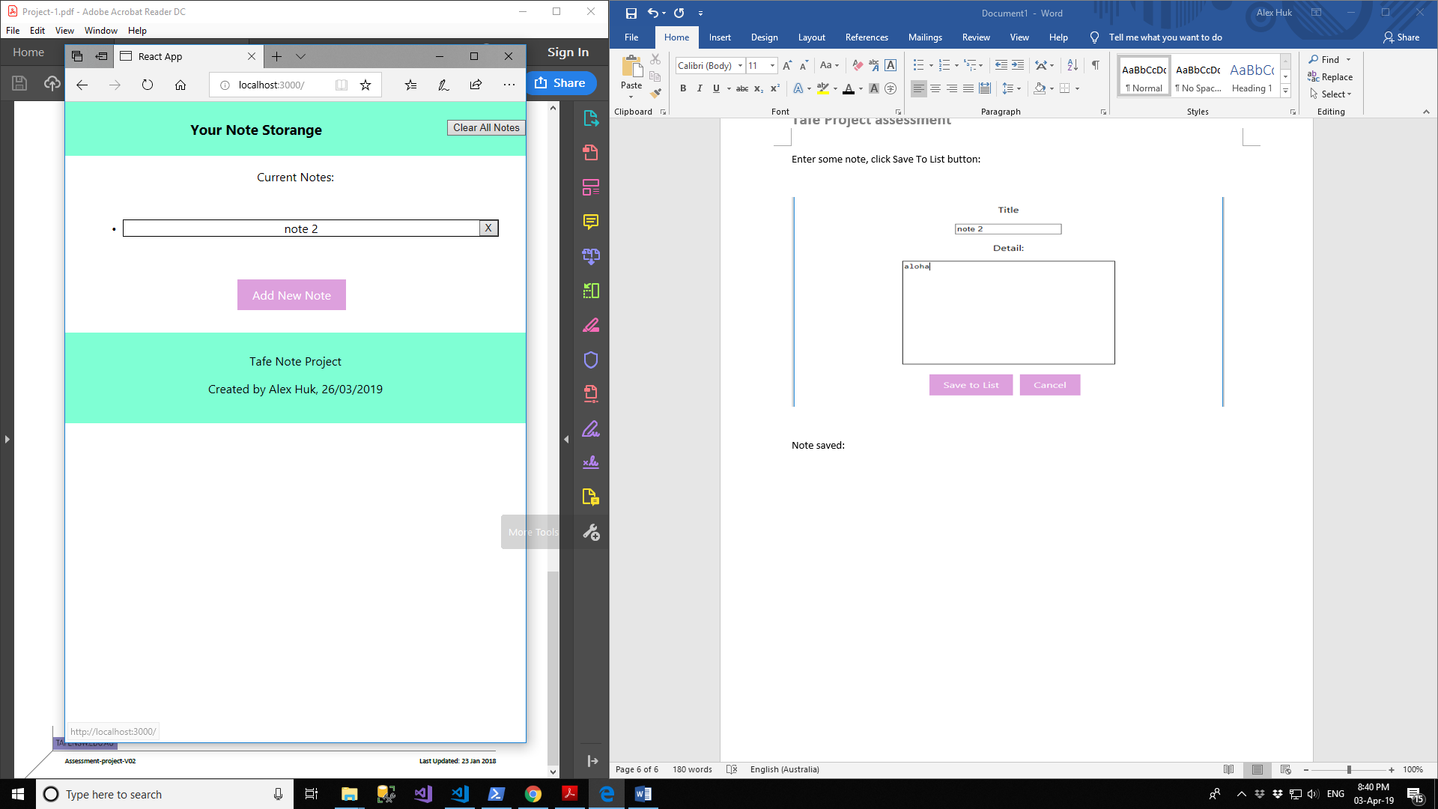

Session Storage:

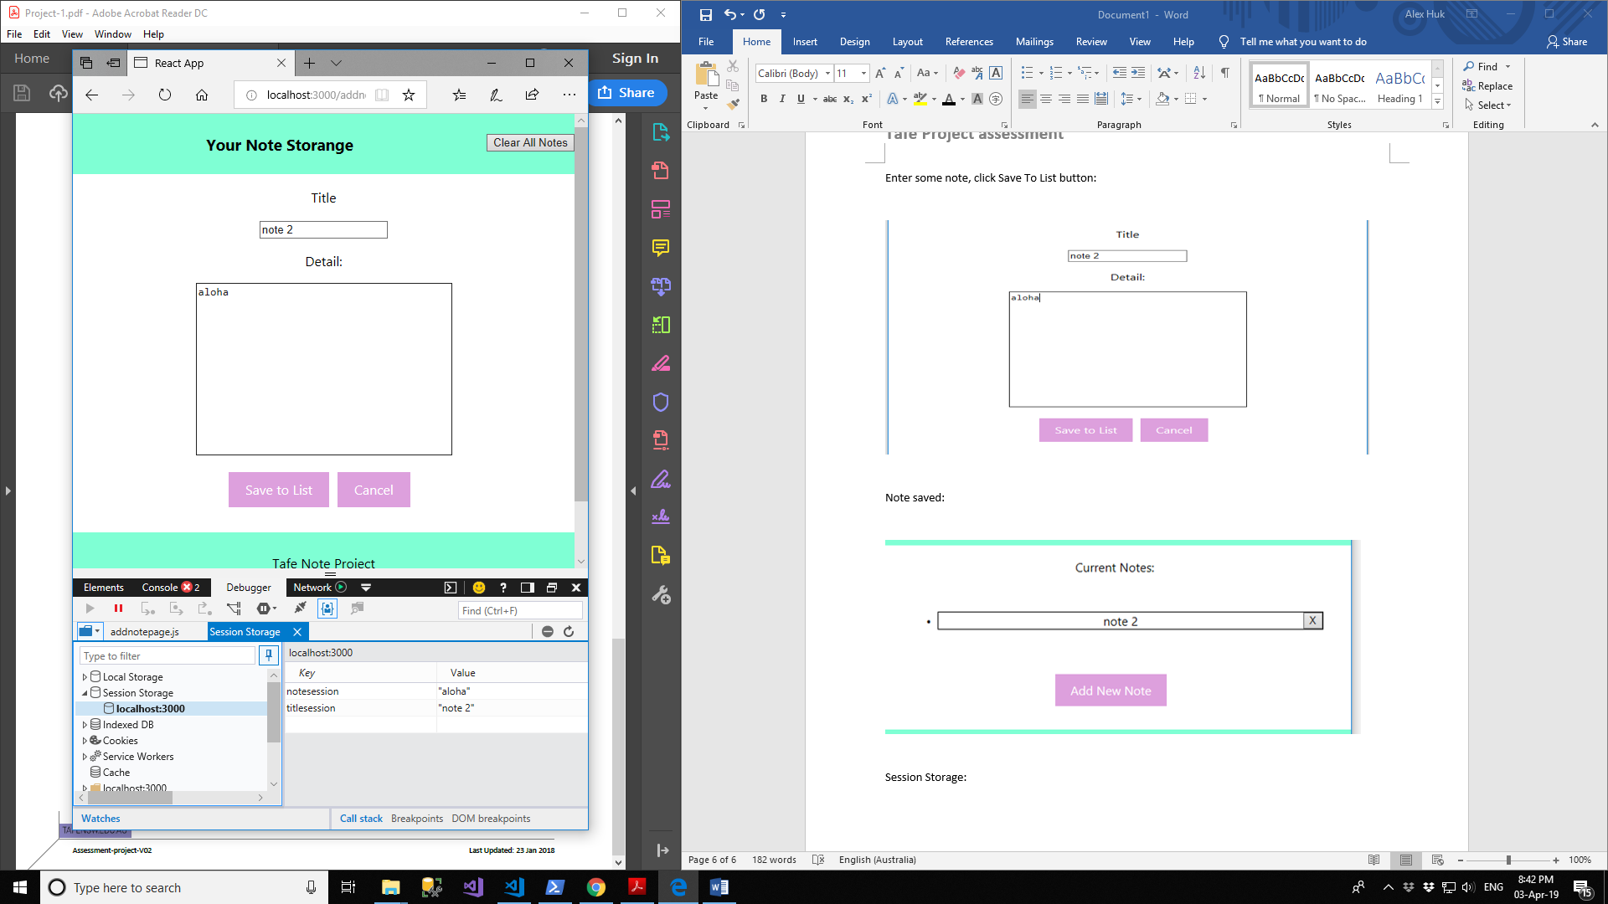

## **Task 5:** Create an Edit Note page

### Display:

Click on the note want to edit:

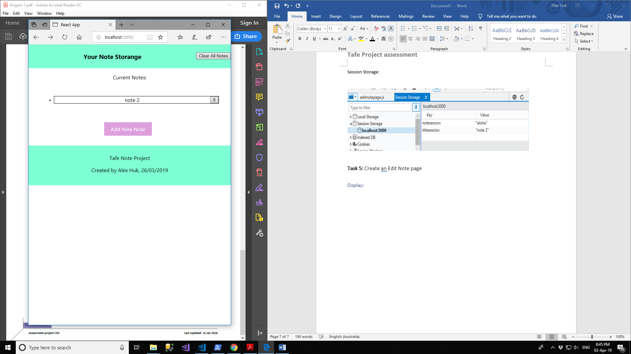

Send to Edit Page:

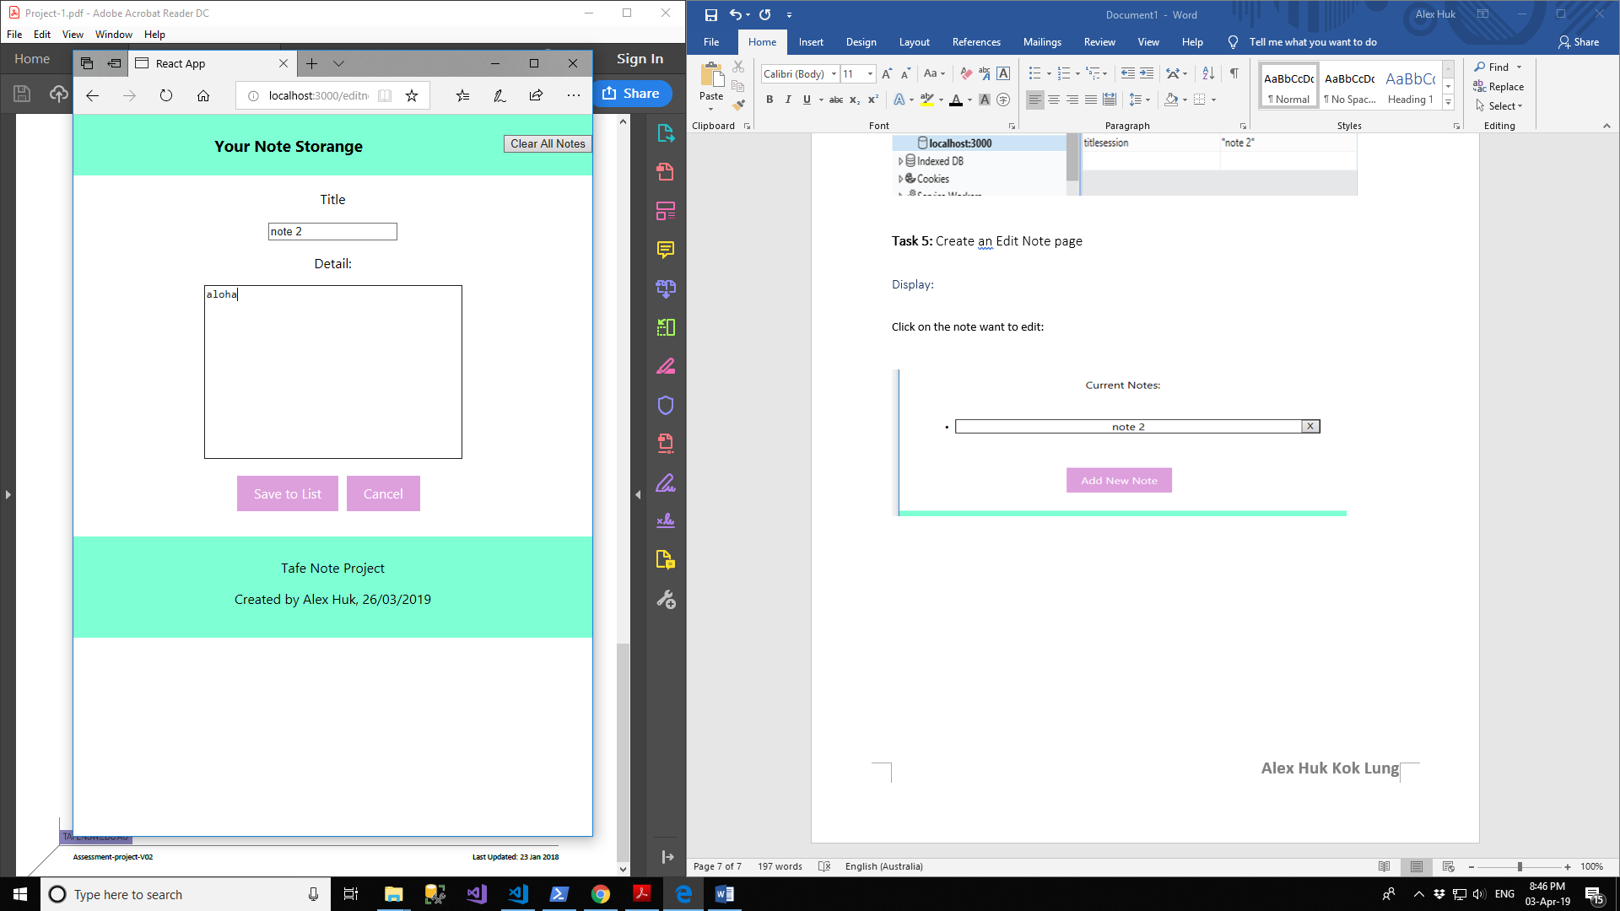

Modify note, and click Save to List button:

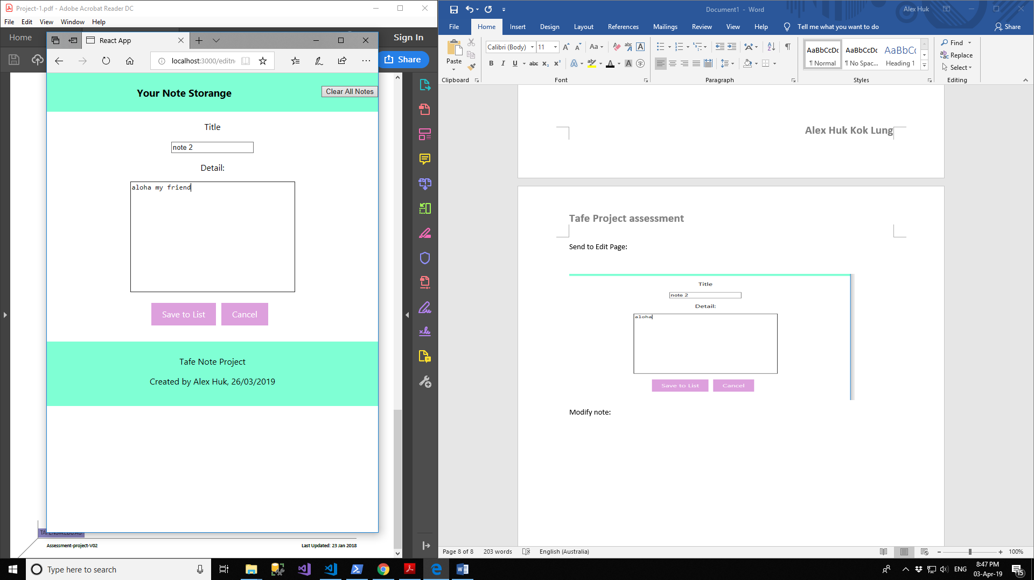

## **Task 6:** Use an npm package

### Code:

Install and import package:

import { ToastContainer, toast } from 'react-toastify';

import 'react-toastify/dist/ReactToastify.css';

onRowDelete(i){

// get the list from storage

let list = JSON.parse(localStorage.getItem('list'));

// remove i

list.splice(i, 1);

// save back into storage

localStorage.setItem('list', JSON.stringify(list));

// not generic code

this.setState({ list });

toast.info('Deleted');

}

render(){

return(

<div>

<p>Current Notes:</p>

<ul className="listbody">

{this.renderRows()}

</ul>

<ToastContainer />

<br />

<Link to="/addnotepage">Add New Note</Link>

</div>

)

};